NAME : | Ms Neerja Doshi
UID : | 2021300029
DIV : | SE CE Div A
DAA Expt 10 Approximation algorithms (The vertex-cover problem)

AIM : | Approximation algorithms (The vertex-cover problem)
ALGORITHM : | - A vertex cover of an undirected graph is a subset of its vertices such that for every edge (u, v) of the graph, either ‘u’ or ‘v’ is in the vertex cover.  - Time Complexity :  - O(n^3  - Algorithm :  - Initialize the result as {}  - Consider a set of all edges in given graph. Let the set be E.  - Do following while E is not empty  - Pick an arbitrary edge (u, v) from set E and add 'u' and 'v' to result  - Remove all edges from E which are either incident on u or v.  - Return result
CODE : | #include<stdio.h>  #include<stdbool.h>  // Define the maximum number of vertices  #define MAX_VERTICES 1000  // Define a structure to represent a graph  typedef struct {  int edges[MAX_VERTICES][MAX_VERTICES];  int num_vertices;  int num_edges;  } graph_t;  // Function to read in the graph  void read_graph(graph_t* graph) {  int i, j, v1, v2;  printf("Enter the number of vertices: ");  scanf("%d", &(graph->num_vertices));  printf("Enter the number of edges: ");  scanf("%d", &(graph->num_edges));  // Initialize all edges to 0  for (i = 0; i < MAX_VERTICES; i++) {  for (j = 0; j < MAX_VERTICES; j++) {  graph->edges[i][j] = 0;  }  }  // Read in the edges  printf("Enter the edges (v1 v2): \n");  for (i = 0; i < graph->num_edges; i++) {  scanf("%d %d", &v1, &v2);  graph->edges[v1][v2] = 1;  graph->edges[v2][v1] = 1;  }  }  // Function to find the vertex cover using a simple approximation algorithm  void vertex_cover(graph_t* graph) {  int i, j;  bool visited[MAX_VERTICES] = {false};  // Traverse the edges and mark the vertices that are connected  for (i = 0; i < graph->num_vertices; i++) {  for (j = 0; j < graph->num_vertices; j++) {  if (graph->edges[i][j] == 1) {  visited[i] = true;  visited[j] = true;  }  }  }  // Print out the vertex cover  printf("Vertex Cover: ");  for (i = 0; i < graph->num_vertices; i++) {  if (visited[i]) {  printf("%d ", i);  }  }  printf("\n");  }  // Main function  int main() {  graph_t graph;  // Read in the graph  read_graph(&graph);  // Find the vertex cover  vertex_cover(&graph);  return 0;  }
OUTPUT : | 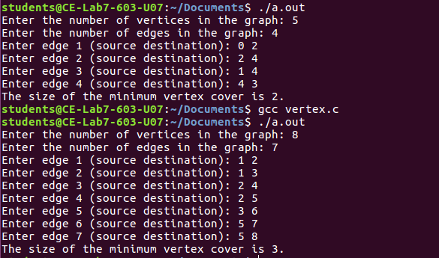
CONCLUSION : | By Performing the above experiment , Ive understood the code and algorithm of Vertex Cover Problem

